**CS 550 Final Project Proposal**

**SUN-EARTH-MOON**

**CHI CHIEH WENG**

**wengchic@oregonstate.edu**

1. **The text from your proposal**

For the final project, I want to build a Moon, Earth, Sun, Star, and meteor. The figure 1 is a demo diagram. I will try to build interesting things on the moon, such as tables, chairs, lamps, and make the perspective of sitting on a chair to watch the earth.

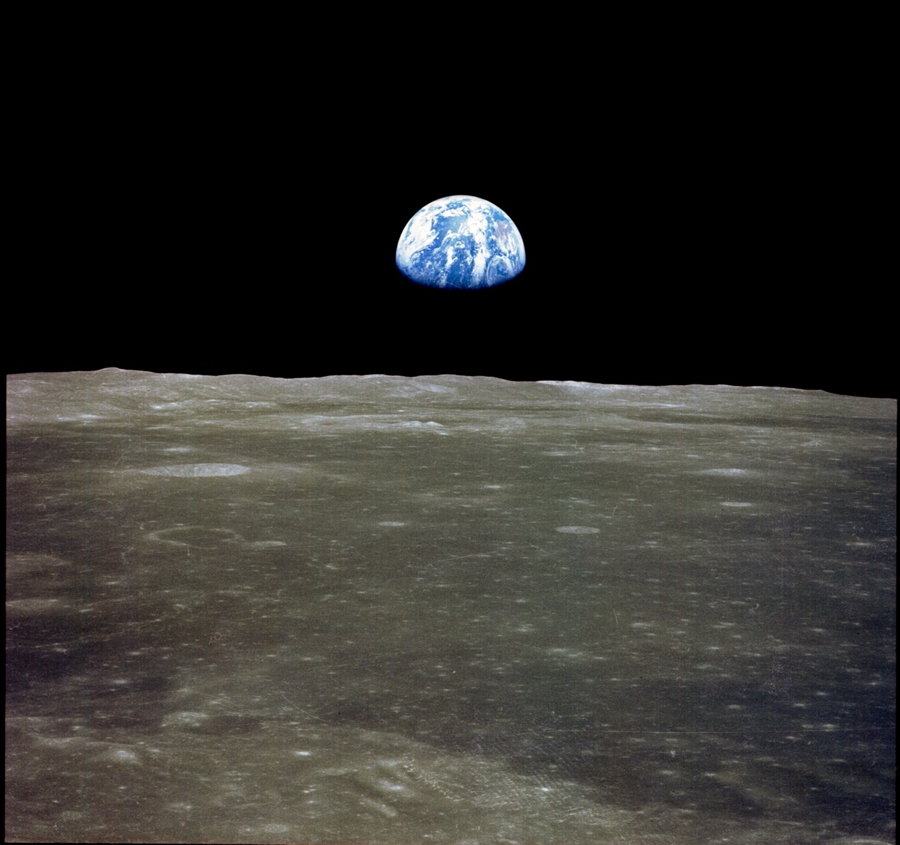

Reference: <https://www.quora.com/Do-we-have-to-look-up-or-down-from-moon-to-see-earth> (Figure 1)

Method details:

A. **obj.file** – Load some obj.file like chair, table, lamp

B. **Texture map** – like Sun, Earth, Moon (The Moon will use displacement texture, and it makes the Moon more like real)

C. **Animation** - Planets and meteors will move.

D. **Light** – like Sun, Star, meteor, and lamp.

E. **Lookat** - You can see somewhere on the earth from somewhere on the moon. (When you look at the earth from the moon, there will be some tables, chairs and a lamp next to you. If you are lucky, you will see some meteors. The meteors may be larger than real, because it is convenient for us to observe.)

1. **What you actually did for your project, with images**

First, I used the Osusphere function to create the Sun, Earth, and Moon, and added some textures to them. 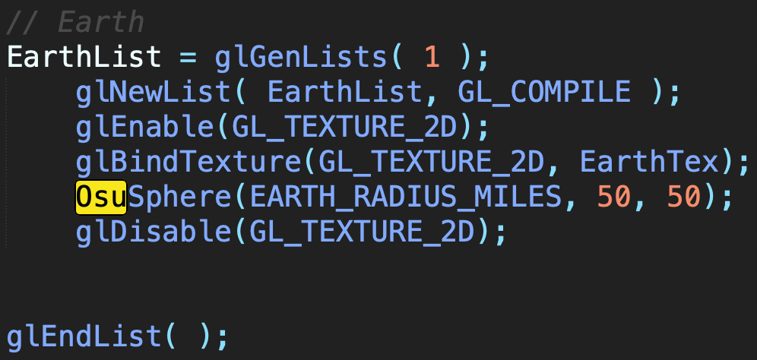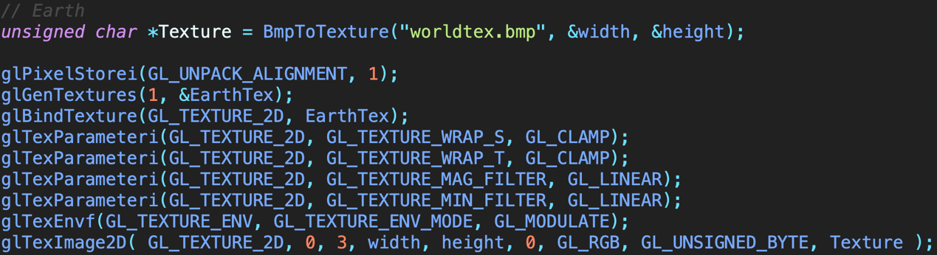

There are 3 different ways of viewing, watch on Earth or Moon or outside.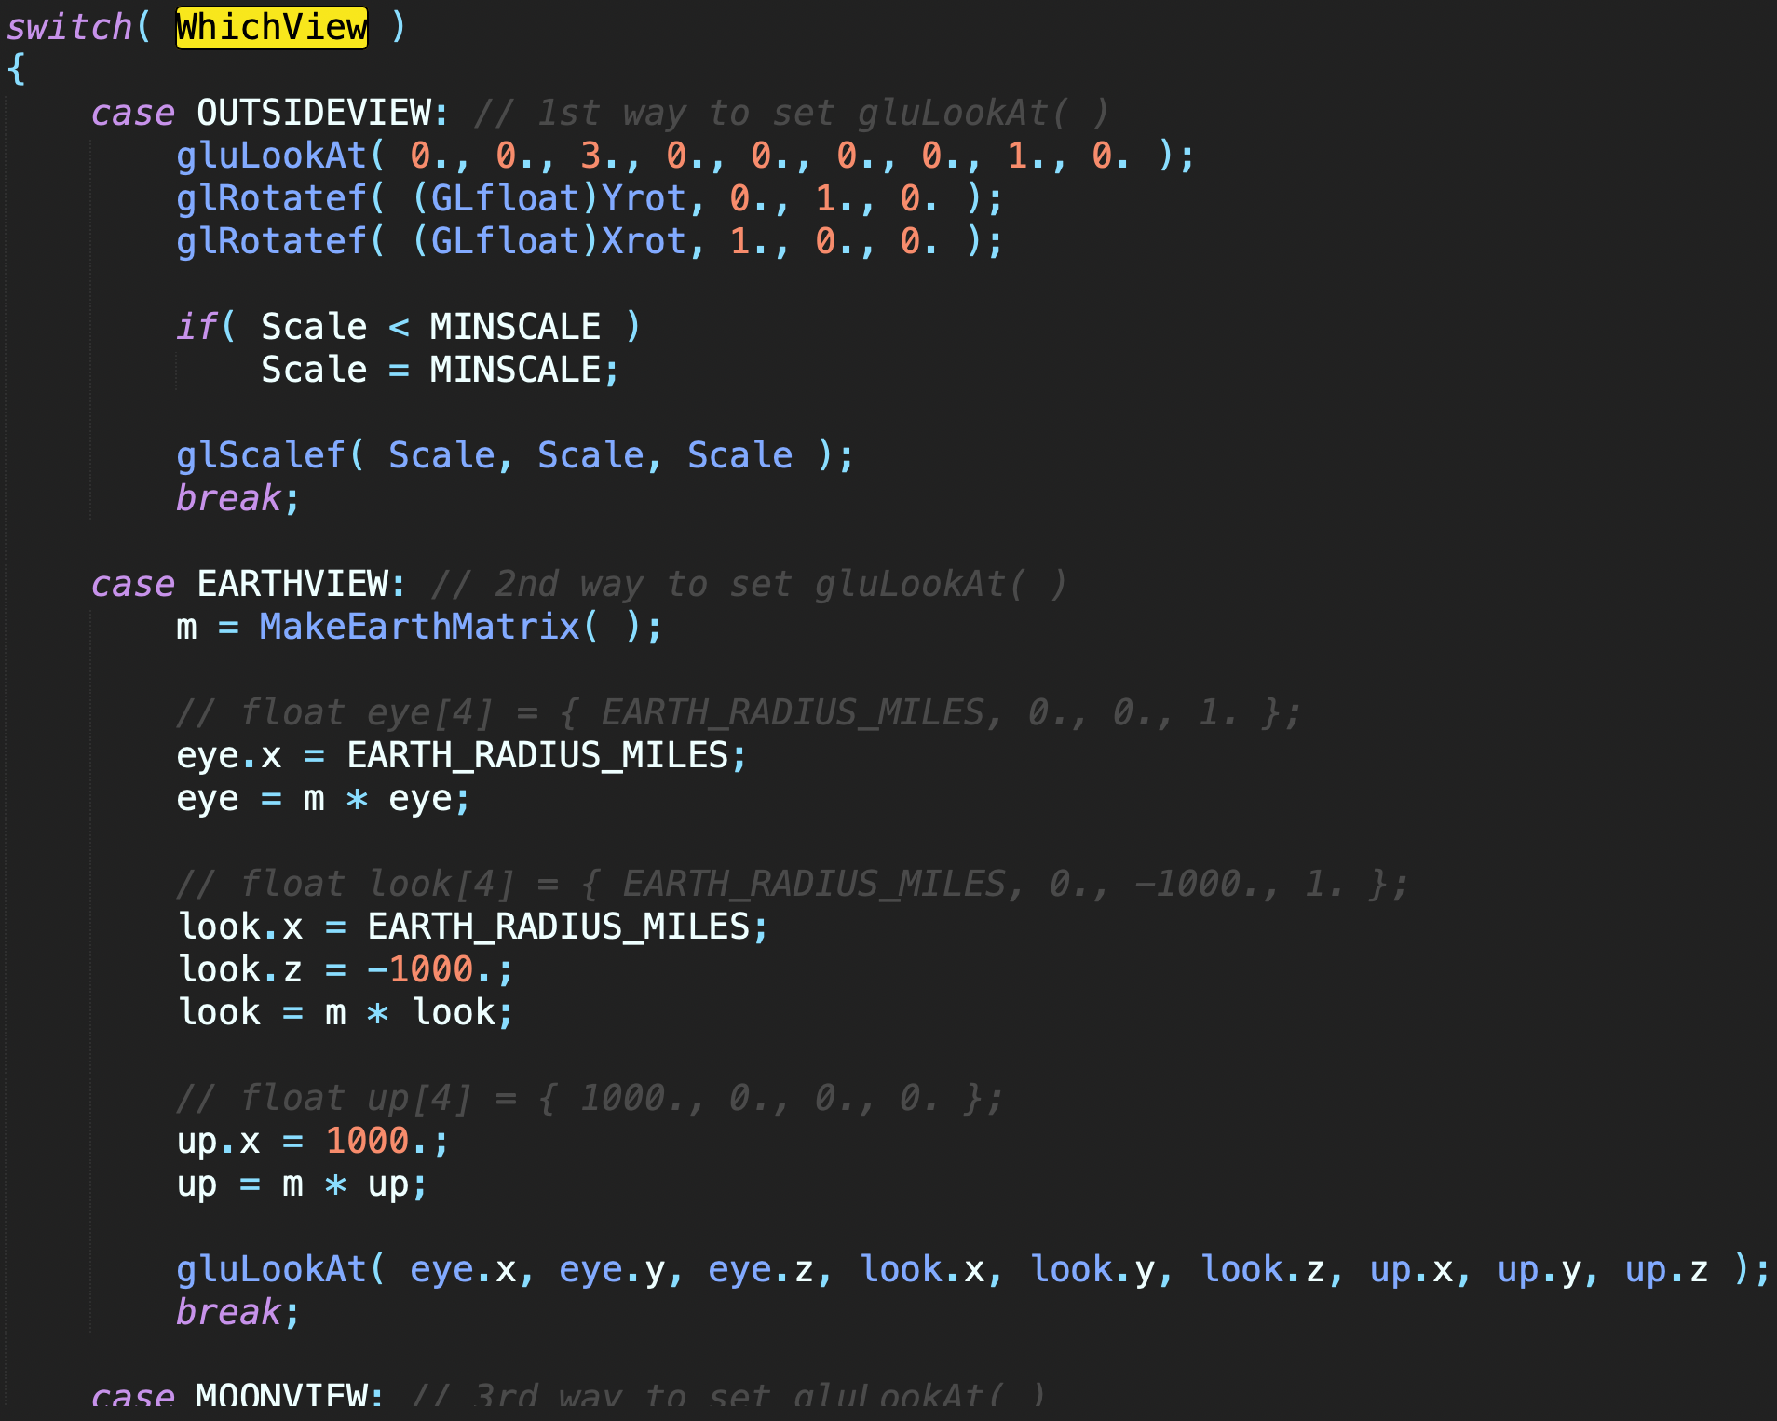

I created stars and they appear randomly somewhere.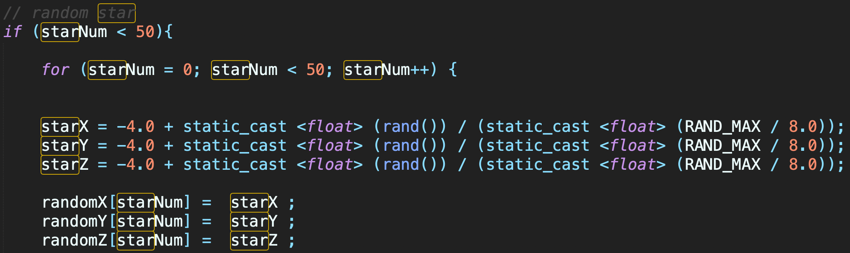

Some stars will move.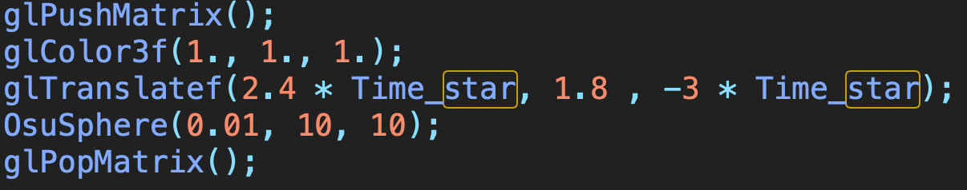

I used the obj file and put it on the moon.

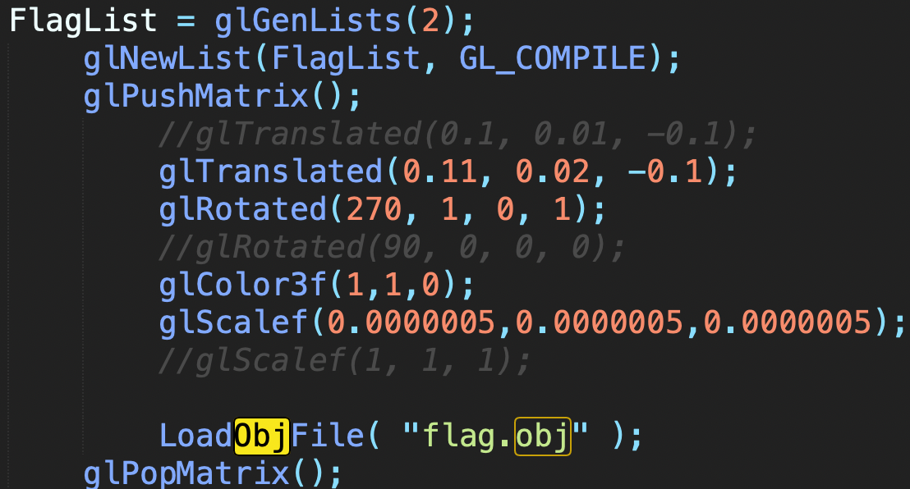

Final, I set the spotlight on the sun.

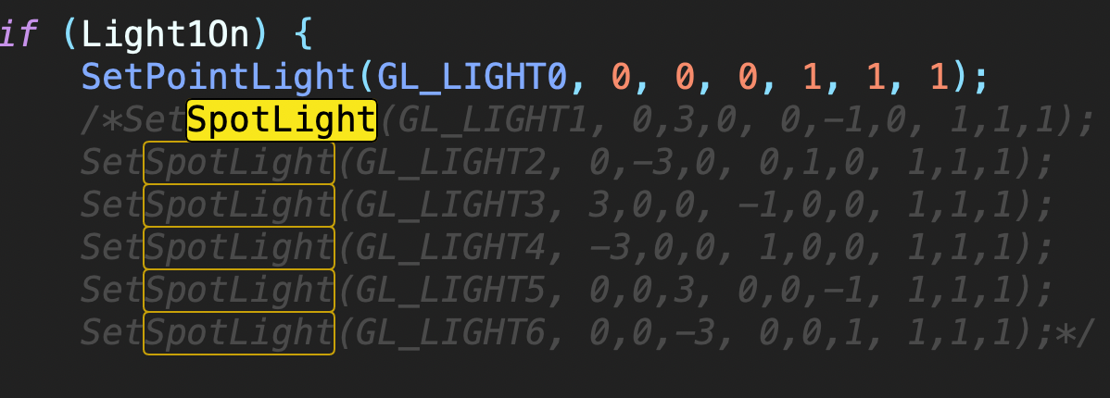

1. **How your project differs from what you proposed, and why**

There are three things that are different from what I proposed. First of all, I did not create the obj.file for chairs, tables and lights. Instead, I created the obj.file for the flag, and that's because I think the flag feels more suitable for placing on the moon. Second, I didn't let those stars shine, because after I let the sun shine, I found that the brightness was enough, and it was more like the actual situation. Final, I failed to make the moon use displacement texture.

1. **Any impressive cleverness you want us to know about**

If I want to make the flag move with the moon and make the flag visible from the perspective of the moon, I must make the flag move synchronously with the moon. Therefore, I put glCallList (FlagList) into the matrix of the moon so that I can achieve the effect.

1. **What you learned from doing this project (i.e., what you know now that you didn't know when you started)**

In the beginning, I set SetPointLight on the sun to give it a sunlight effect, but found that the sun had no texture and was very dark, so I used SetSpotLight to illuminate the sun. ​However, I remembered that I can use glTexEnvf (GL_TEXTURE_ENV, GL_TEXTURE_ENV_MODE, GL_REPLACE) to make the sun not dark and have texture. Although both methods can keep the sun bright, but the second method may be better for the time complexity of the program.

1. **Some images that are especially representative of what you did**

Keyboard 0, 1, 2, 3, 4 have their own different functions

**'0' is all lighting effects**

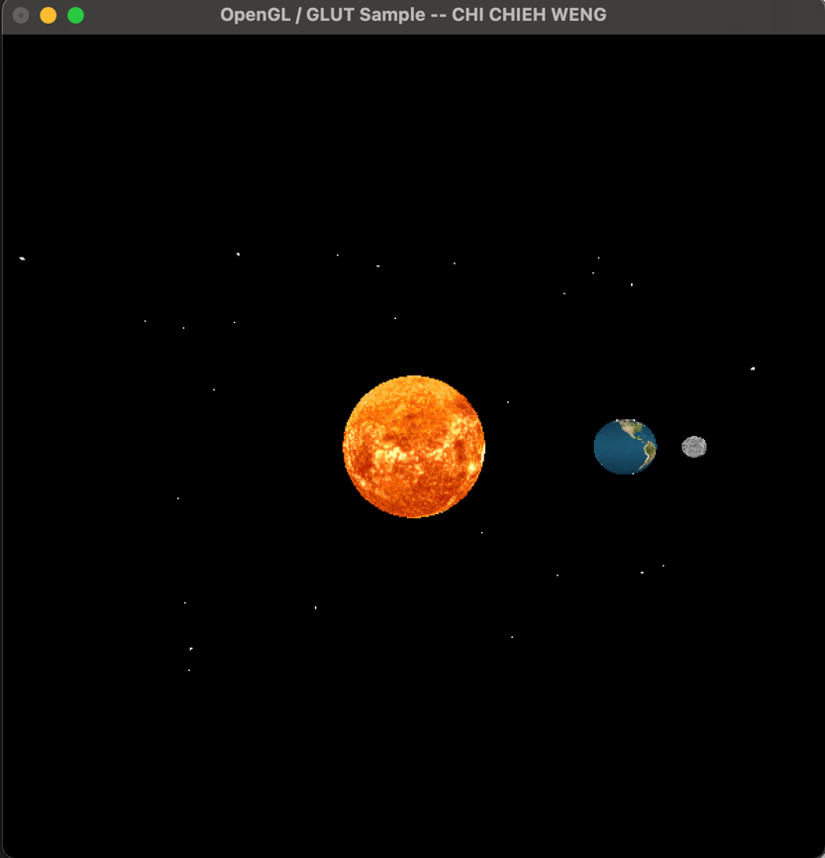 Open all light

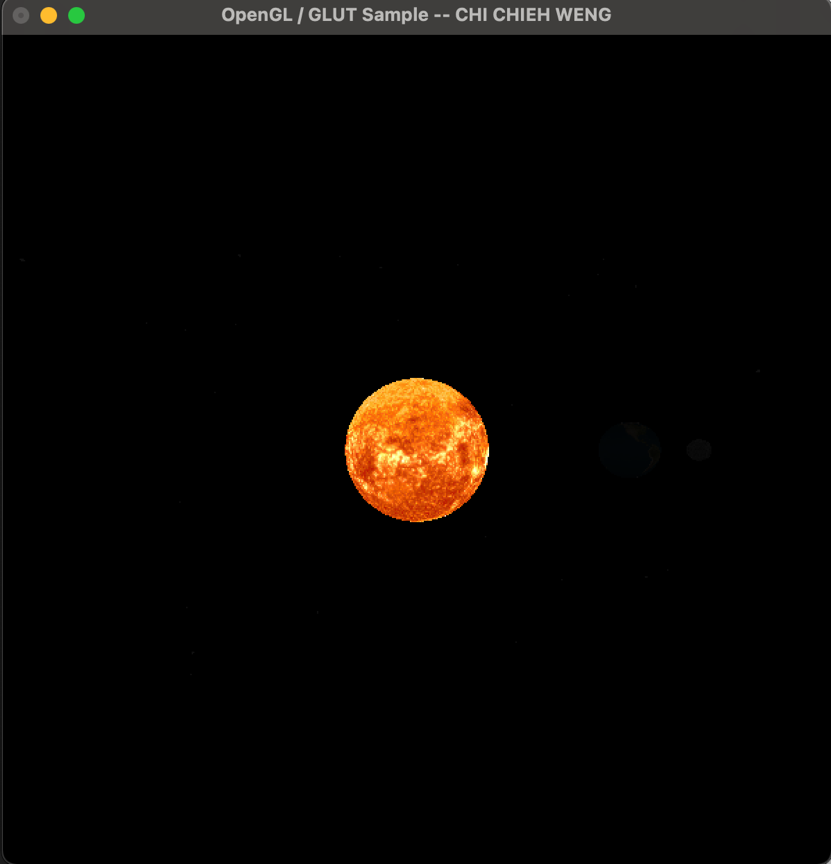 Close all light

**'4' is sunshine effects**

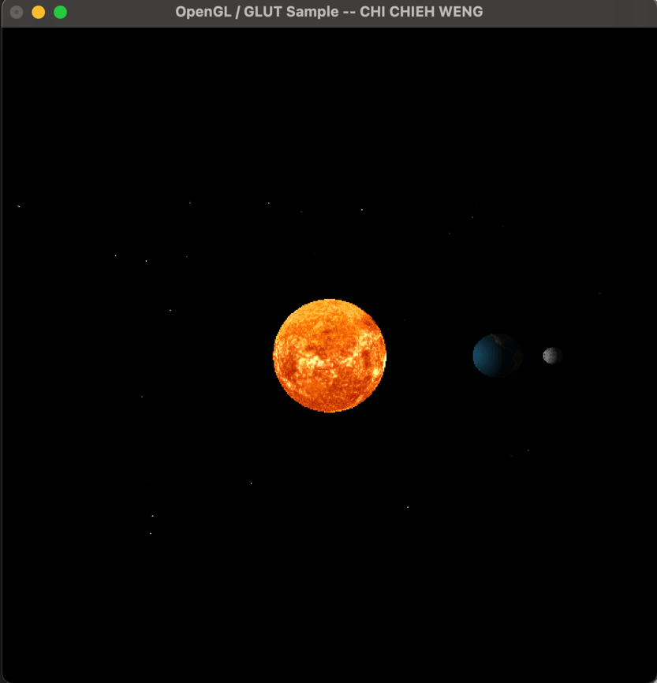 Only sunshine

**'1' is outside view**

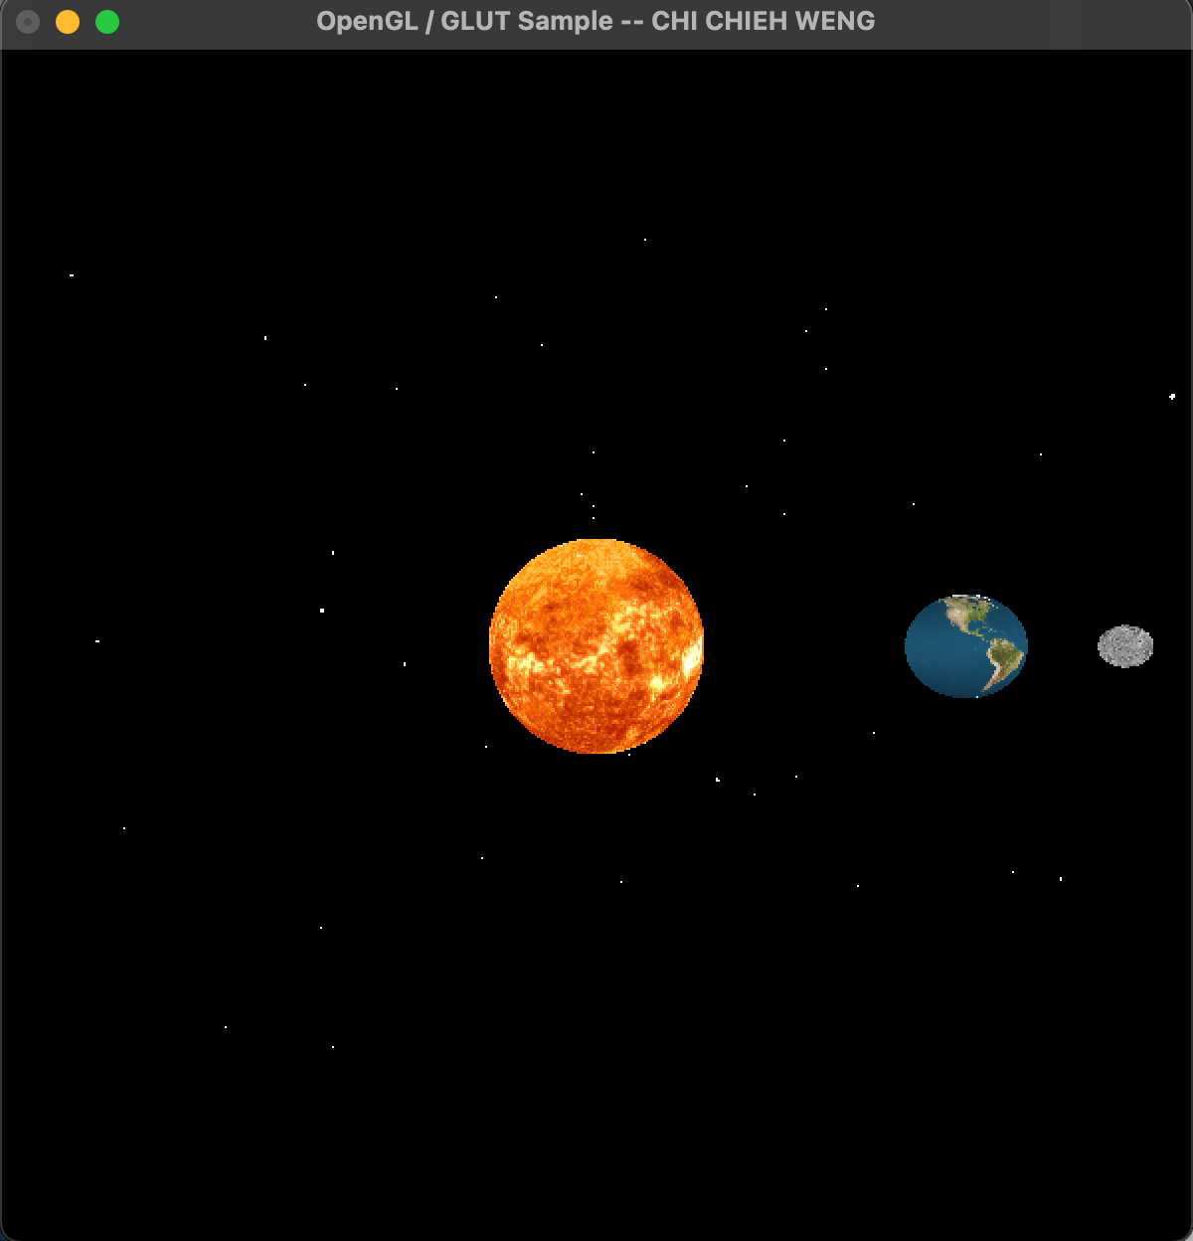 Open all light

**'2' is Earth view**

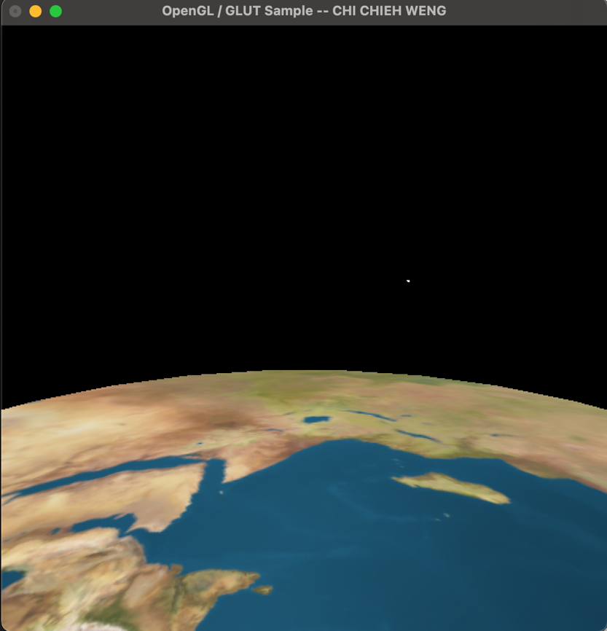 Open all light

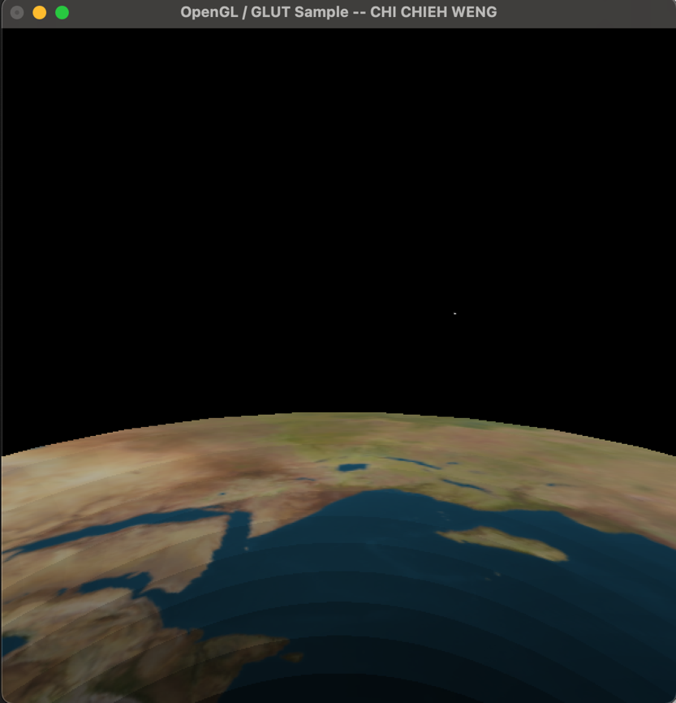 Only sunshine

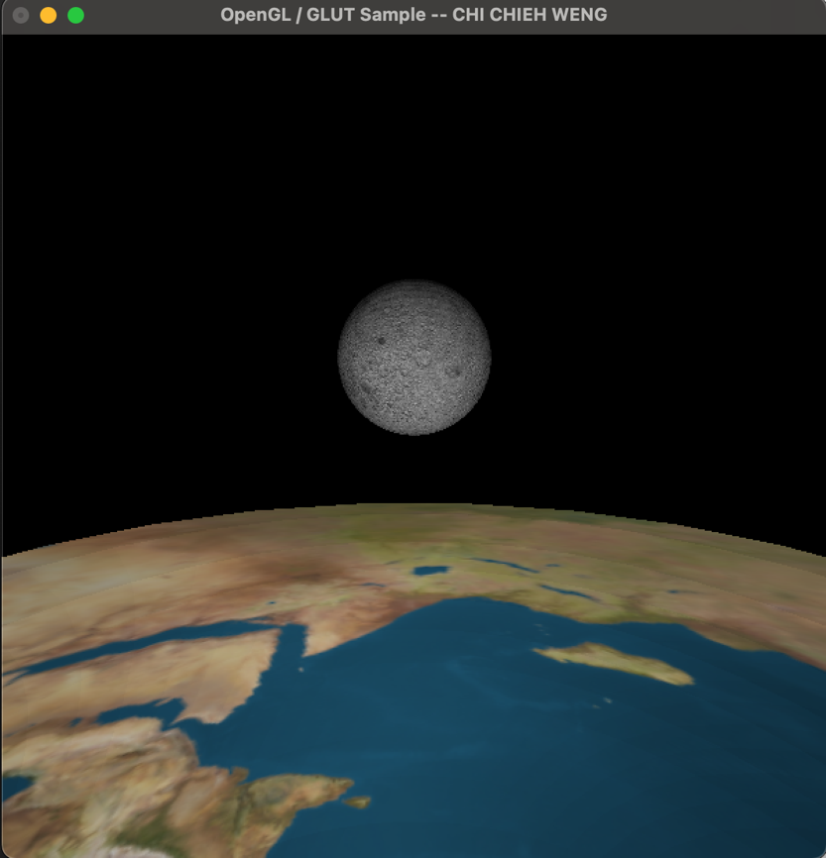 Only sunshine

**'3' is Moon view**

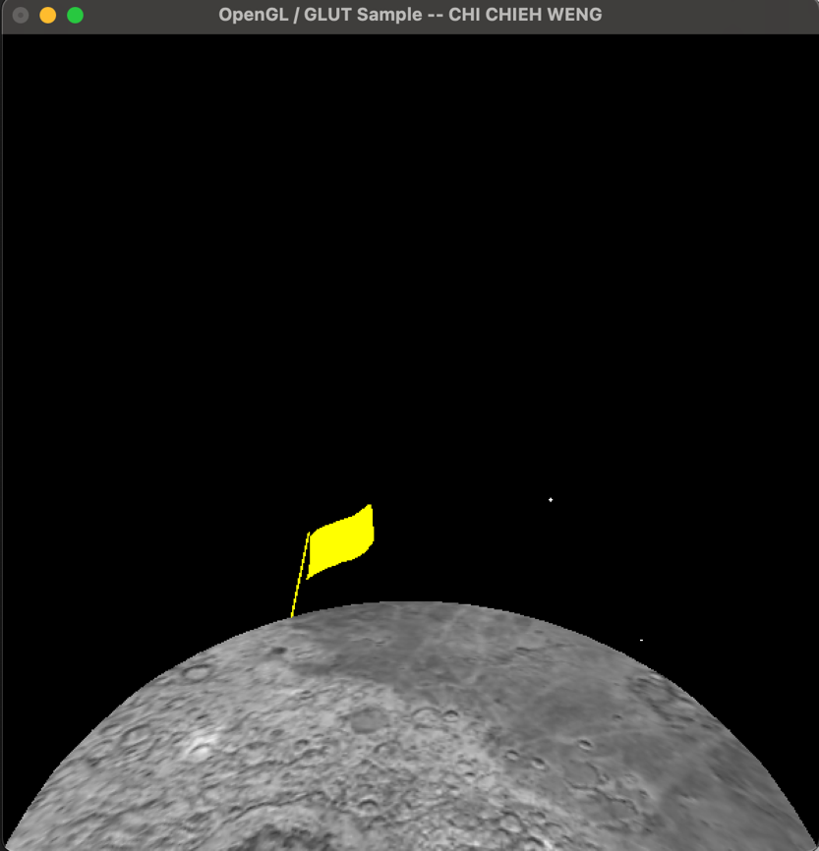 Open all light

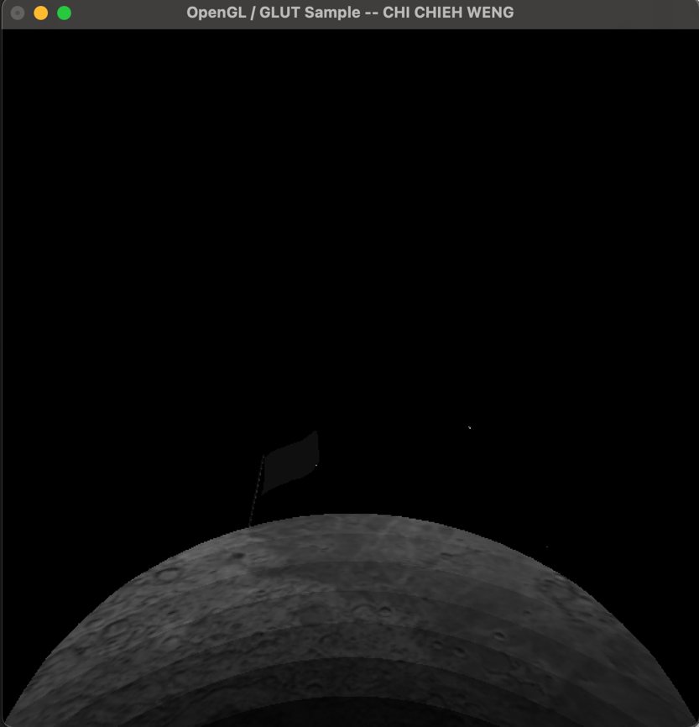 Only sunshine

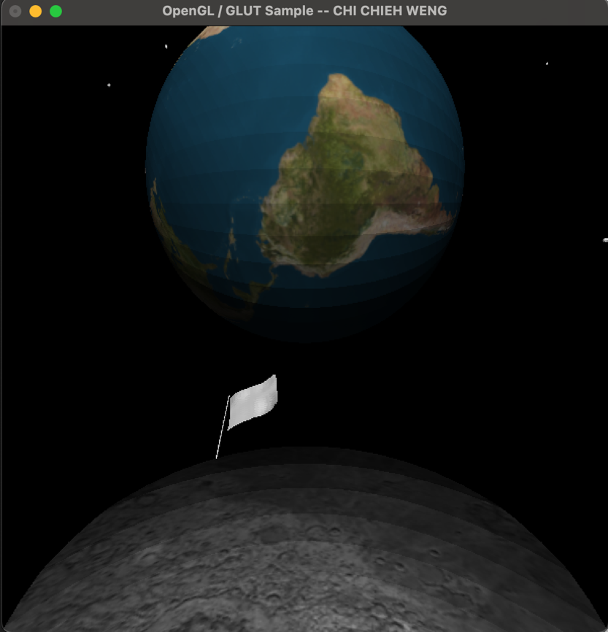 Only sunshine

The distance and size between the planets are changed according to the actual data, but not adjusted according to the proportion, so the moon will look slightly smaller. (The view of the moon will make the land area of the moon not so big)

1. **A link to the video showing off your project.**

https://media.oregonstate.edu/media/t/1_olp2r9t8